Second Generation Multi-Station Polymer Creep-Tester Machine

Team Members: Ricardo O. Jacome, Rolando Garcia, Jon P. Stutz & Jose O. Moya  
Faculty Advisors: Dr. Robert Jones & Mrs. Samantha Ramirez

This project consists of building a Creep-Tester capable of loading 5 samples with varying weights and exposing them to different failure modes in order to investigate for material properties. Creep is defined as the time-dependent property of a solid material to deform permanently under the influence of mechanical stresses at a fixed temperature (about 40% of the melting temperature). Creep testers are implemented in research and industry in order to improve and discover new uses for materials. An example is the automotive industry in which the new vehicles come with a special cover that goes on top of the cylinder head cover. This cover tends to be an air duct for ventilation that also serves for protection of the cylinder head cover. Even though this part is not in full contact with the motor, it is exposed to high temperatures while functioning. Therefore, creep research needed to be performed for this product to be commercialized. Furthermore, market research shows that there are not many competitors that use failure modes other than tensile, for which having this could commercialize into the research and development areas private companies. Finally, this product offers an enhancing experience for students in a learning/research settings in universities. The design was focused on university classroom settings; thus the methods of operation tend to be involved for the students to become proficient and confident on equipment usage.

Referring to the Creep-Tester machine, the proposed design consists of interchangeable specimen grips that will provide for three different types of failure modes: Tensile, Compression, and Bending. The customer is free to use any configuration of testing that involves different failure modes with 5 samples. This provides means to reduce testing time while still maintaining a reliable statistical failure analysis. The project is composed of a Convection Temperature Oven for uniform temperature distribution. A Data Acquisition System composed of one thermocouple and one potentiometer per sample which can send the readings through an Arduino interface and then export the raw data through Python into an Excel spreadsheet that the customer can use. The Weightlifting Mechanism consists of a crank shaft mechanism that has a gearbox for torque amplification and being able to move up or down sample weights providing a quasi-static loading. These weights can be changed as well, and all of them will be connected each to one rod that has a grip holding one specimen. Manuals of Operation and Maintenance are provided on the links below, also a picture of a SolidWorks file is provided along with a picture of the final product along with a video demonstration of the product working.

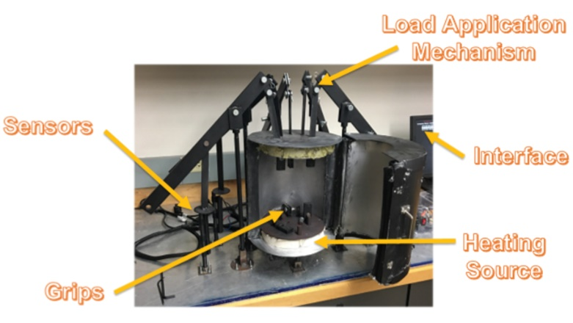

Figure 1 – First Generation Creep Tester Machine

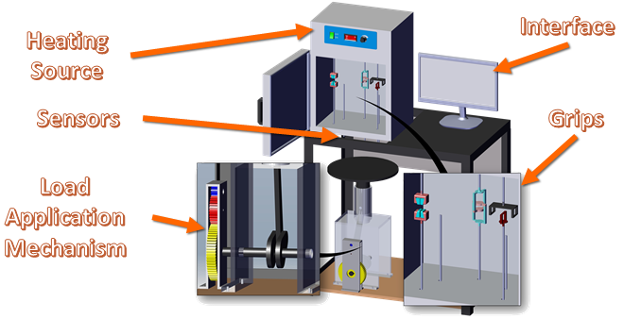

Figure 2 – Second Generation Creep Tester Model

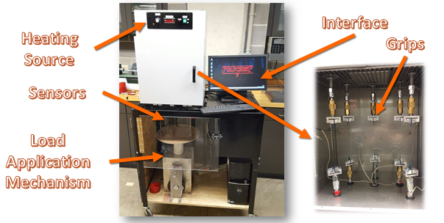

Figure 3 – Second Generation Creep Tester Machine